Pillars of Faith
Lections from the RCL
 | Aug 7/Proper 14 | Aug 14/Proper 15 | Aug 21/Proper16 | Aug 28/Proper 17
Psalm | Psalm 50:1-8, 23-24 | Psalm 80:1-2, 8-18 | Psalm 71:1-6 | Psalm 81:1, 10-16
1st  Reading | Hebrews 11:1-3, 8-16 | Hebrews 11:29-12:2 | Hebrews 12:18-29 | Hebrews 13:1-8, 15-16
2nd  Reading | Luke 12:32-40 | Luke 12:49-56 | Luke 13:10-17 | Luke 14:1, 7-14

Music Suggestions
- All music is available from Amazon Music or iTunes.
- Consider purchasing Amazon Prime “unlimited” streaming which is about $8.00 a month, and stream directly from a playlist you can quickly create from their site. Otherwise, each MP3 must be purchased individually.
- Mix it up – if you have an organist or musician, use them for community singing and stream other pieces.
- After the music suggestions grid, there are copies of the hymns for opening and closing. These hymns use familiar tunes (many are found in The Hymnal 1982) but may have alternate words.
- Although there seems like a lot of “rock” references, the music itself varies so widely it isn’t repetitive.
- Listen to everything before the service – some recordings have fewer verses for singing.
- Report your use of this music to the licensing service through the Episcopal Church of Wyoming.
- As always, adjust to suit your congregation.

 | Aug 7/Proper 14 | Aug 14/Proper 15 | Aug 21/Proper16 | Aug 28/Proper 17
Prelude | “My Hope is Built on Nothing Less”  David Nevue -  Adoration: Solo Piano Hymns | “Rock of Ages Cleft for Me”  Sovereign Grace Music & Bob Kauflin - Upward | McCartney: Safe haven/standing stone. Pastorale con moto -  London Symphony Orchestra & Lawrence Foster | “A Mighty Fortress Is Our God: Symphony No. 5”  Tim Zimmerman And The King's Brass - Classic Hymns
Opening Hymn | “How Firm a Foundation”  Russell Woollen - Journeysongs Third Edition: Volume 22 | “Christ Is Made the Sure Foundation”  OCP Session Choir - Journeysongs Third Edition: Volumer 25 | “Healing River of the Spirit”  Ruth Duck - Journeysongs Third Edition: Volume 17 | “Living Faith”  TUNE: Faith of our Fathers (St Catherine) John Keys - Devotional Hymns, Vol. 4
Offertory | “Rock a My Soul”  Chanticleer - On the Air: Live Radio Highlights | “My Rock”  The Fairfield Four -  Still Rockin My Soul | “A Rock for All Ages”  Ben Tavera King - Amazing Grace & It's Variations | “On Christ the Solid Rock I Stand”  Michael Lusk - Peaceful Violin Worship
Communion | “Rock Of Ages”  Chris Rice - Peace Like A River: The Hymns Project | “O God The Rock Of Ages”  Grace Chicago Consort - Sounding Grace | “Healing Hands”  Hannah Grace - Remedy | “Built On The Rock The Church Doth Stand”  Tine Thing Helseth - My Heart Is Ever Present
Communion | “Solid Rock”  Page Cxvi - Hymns | “Rock of Ages”  Gillian Welch -  Hell Among the Yearlings | “The Church's One Foundation”  Ruben Alves -  Revisiting Hymns | “Shelter Me, O God”  Bob Hurd, Anawim - In the Breaking of the Bread
Closing Hymn | “Great is Thy Faithfulness”  The Celebration Choir - The Best Hymns Album in the World…Ever | “O Christ the Great Foundation”  TUNE: Aurelia, (alternate words)  John Keys - Traditional Hymns, Vol. 6 | “The Spirit Sends Us Forth”  Delores Dufner OSB – Journeysongs Third Edition: Volume 27 | “Rock of Ages”  (TOPLADY)  The Redeemer Choir Austin Texas - Redeemer Hymn, General II
Postlude | “Jesus Is a Rock in a Weary Land”  Dave Lemieux -Blue Hymnal | “I Go To The Rock”  Whitney Houston [feat. The Georgia Mass Choir] - The Preacher’s Wife | “Jesus Is My Rock”  Rev. Gerald Thompson - Let the Church Say “Amen” | “Solid As A Rock”  Ella Fitzgerald - Decca Single

How Firm a Foundation
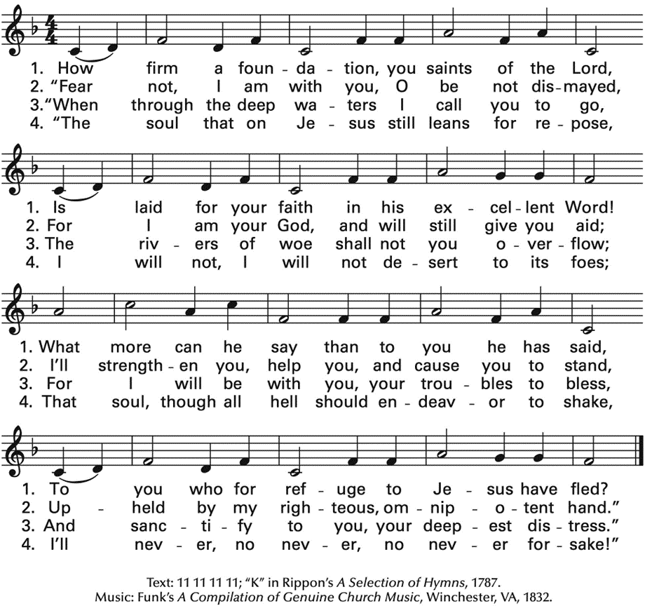

Great is Thy Faithfulness
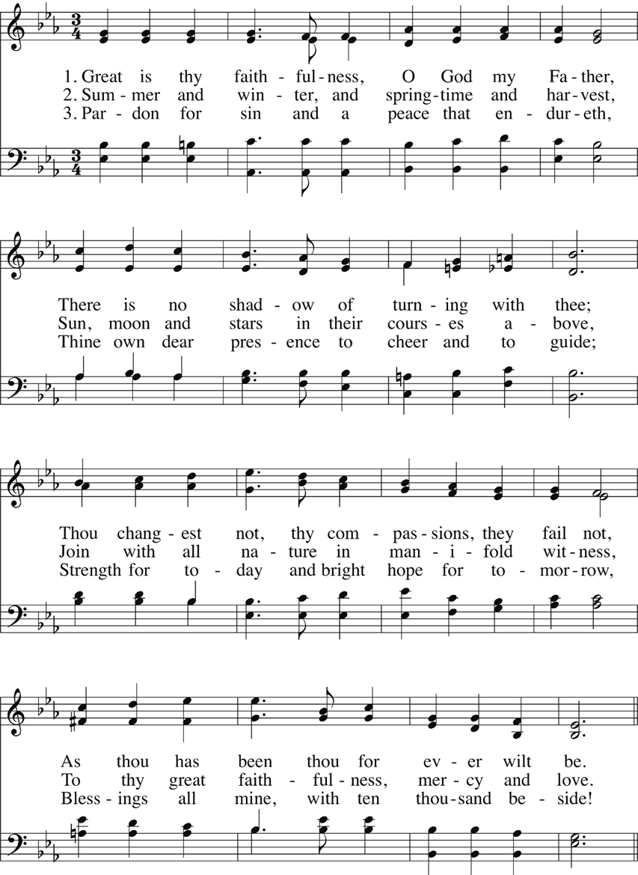
Continued
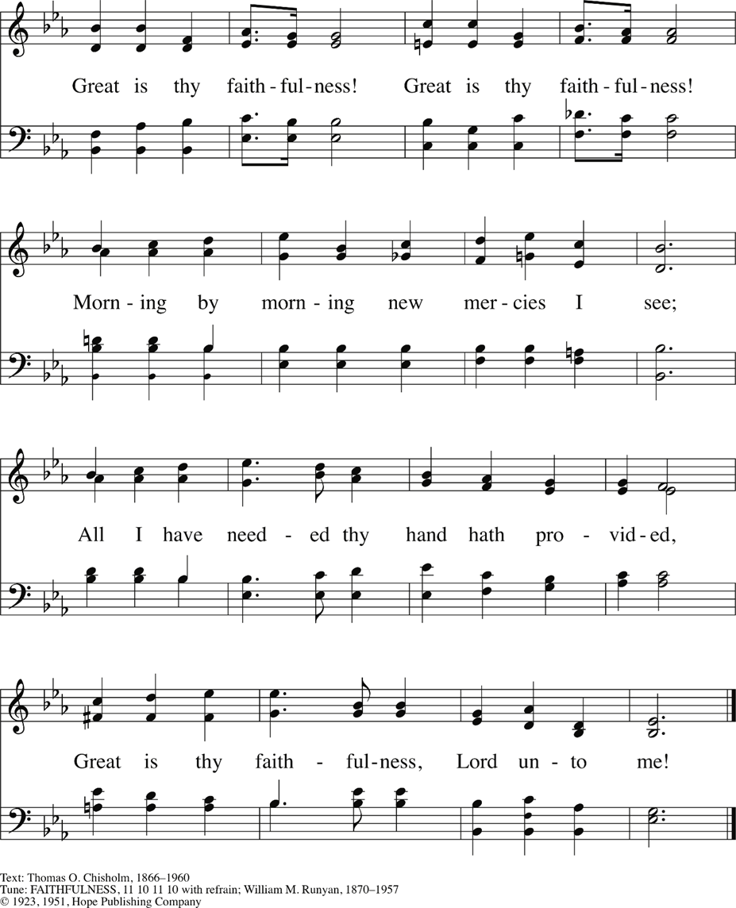

Christ is Made the Sure Foundation
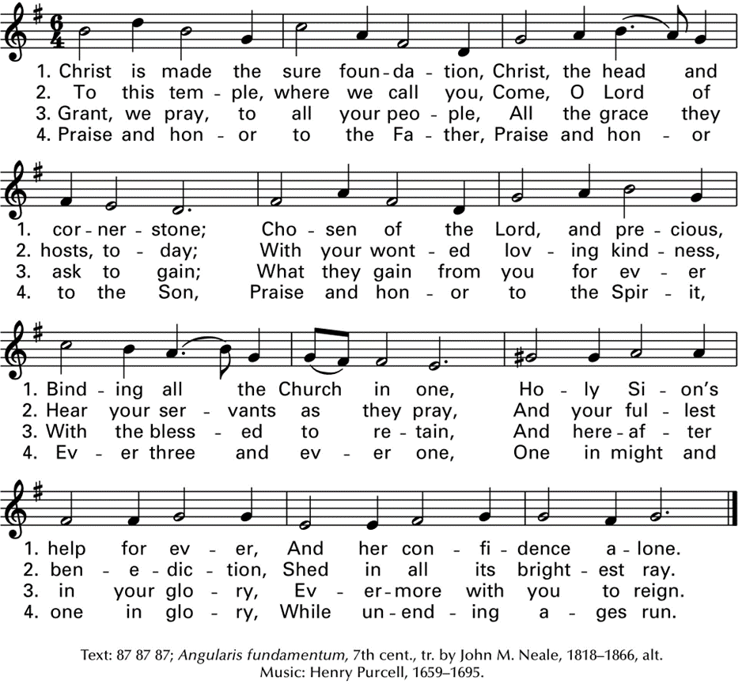

O Christ the Great Foundation
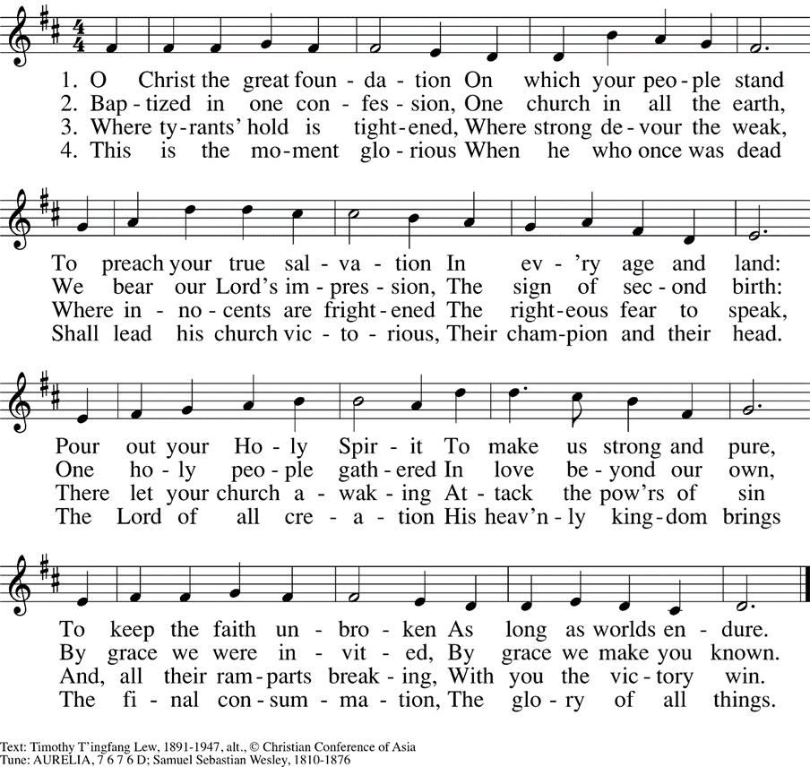

Healing River of the Spirit

The Spirit Sends Us Forth
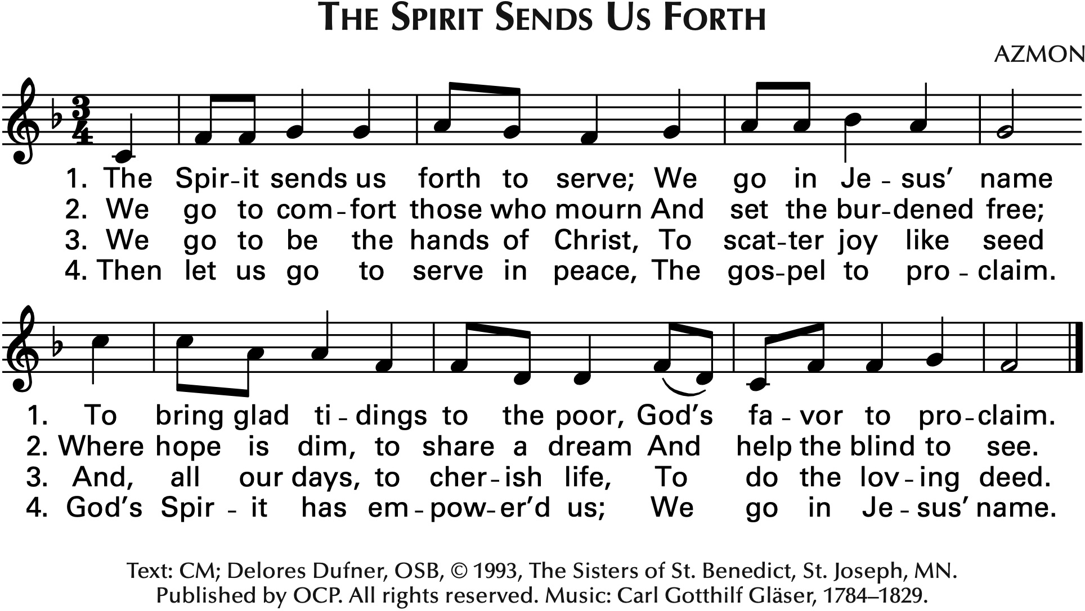

Living Faith

Rock of Ages
